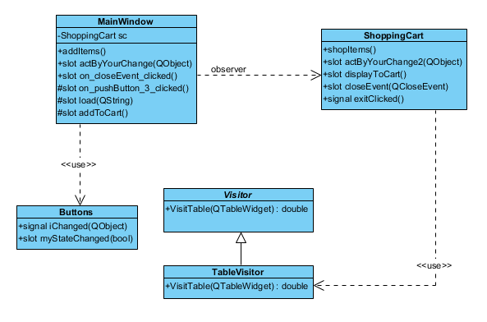

Nikolas Sumnik A55738715

Christopher Nosowsky A53627356